1. Create a Crow’s Foot ERD to include the following business rules for the ProdCo company:
   1. Each sales representative writes many invoices.
   2. Each invoice is written by one sales representative.
   3. Each sales representative is assigned to one department.
   4. Each department has many sales representatives.
   5. Each customer can generate many invoices.
   6. Each invoice is generated by one customer.

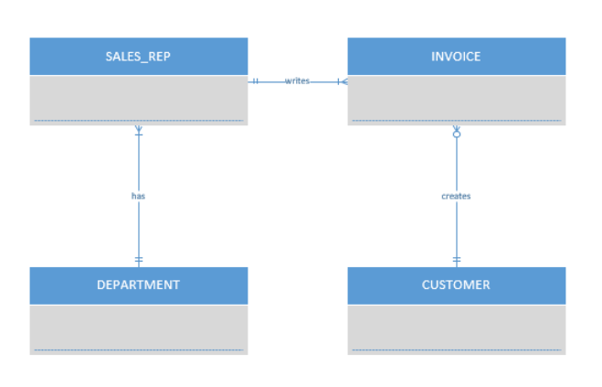

1. Write the business rules that are reflected in the ERD shown in Figure P2.15. (Note that the ERD reflects some simplifying assumptions. For example, each book is written by only one author. Also, remember that the ERD is always read from the “1” to the “M” side, regardless of the orientation of the ERD components.)
   1. Each publisher publishes many books.
   2. Each book is published by one publisher.
   3. Each publisher submits many contracts.
   4. Each contract is submitted by one publisher.
   5. Each contract is signed by one author.
   6. Each author signs many contracts.
   7. Each author writes many books.
   8. Each book is written by one author.
2. Write the business rules that are reflected in the ERD shown in Figure P2.17.
   1. Each theatre shows many movies.
   2. Each movie is shown in many theatres.
   3. Each movie receives many reviews.
   4. Each review is received by one movie.
   5. Each reviewer writes many reviews.
   6. Each review is written by one reviewer.